Embedded Elements - Need

Any website must be able to engage well with its visitors, be entertaining, and be able to quickly deliver information.
Embedding content like audio clips, videos, images, maps, and so on... are a great way of engaging, be entertaining and be able to quickly deliver information to the website users.
Pictures or moving pictures, maps, etc. typically draw user attention and trigger quite a lot of emotions. Humans find it easy to connect to such information, rather than having to go through textual information.
This is why HTML provides tags for embedding media content like audio, video, and images and also for embedding external content like maps.
HTML5 supports the following types of embedded elements:
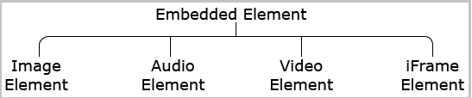

Image Element:
Embedding images to a web page can be done with the <img>...</img> tag. The <img> tag has attributes 'src' and 'alt' where src defines the location of the image and alt defines the alternative text if it is failed to load the image inside the web page.
- <img src="Summit.png" alt="image unavailable"/>
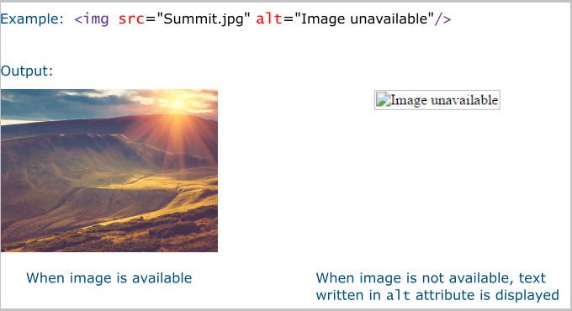
Image Captions

We can also provide a caption for the embedded images.
HTML provides a semantic element <figure> along with <figcaption> element which help us to provide caption for our images.
For example, consider the following code.
- <figure>
- <img src="tropicalSea.jpg"
- alt="An image of tropical sea"
- width="400"
- height="341">

- <figcaption>A colorful tropical sea view</figcaption>
- </figure>
The above code snippet generates an output as below:
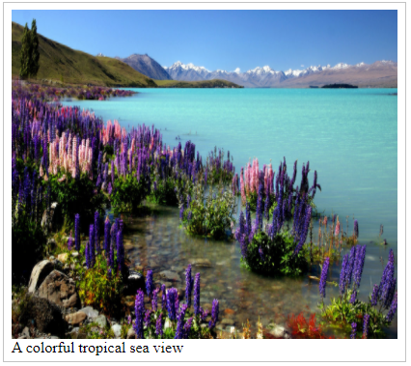
Note: The <figure> element in HTML is commonly used along with a diagram, illustration, or image to represent them as self-contained content.
Audio Element:
Embedding audio to a web page can be done with <audio>...</audio> tag. The <audio> tag has an attribute 'src' which defines the location of the audio file. It also has an attribute 'controls' which specifies whether to display the player controls.
- <audio src="audio.mp3" controls="controls"></audio>
Content between <audio> and </audio> tag will be shown by browsers who do not support audio element.
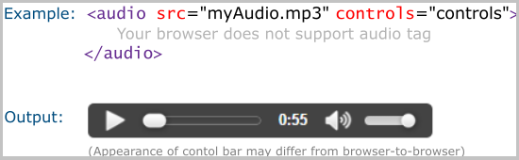
Some of the attributes which are supported by the audio element are as follows:
Attribute | Value | Description
loop | Boolean- any value sets it to true | Loops audio indefinitely
autoplay | Boolean- any value sets it to true | Plays audio indefinitely
preload | none-preloading  metadata- audio metadata is downloaded  auto- entire audio file is downloaded | Specifies whether audio should be preloaded or not
muted | Boolean- any value sets it to true | Mutes audio

Video Element:
Videos can be embedded into web pages using <video>…</video> tag. The <audio> tag has an attribute 'src' which defines the location of the audio file. It also has an attribute 'controls' which specifies whether to display the player controls.
- <video src ="myVideo.mp4" controls="controls"></video>
Content between <video> and </video> tag will be shown by browsers who do not support the video element.
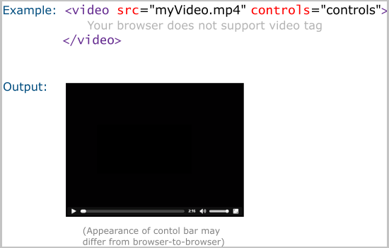
Some of the attributes which are supported by video element are as follows:
Attribute | Value | Description
loop | Boolean- any value sets it to true | Loops audio indefinitely
autoplay | Boolean- any value sets it to true | Plays audio indefinitely
preload | none-preloading  metadata- video metadata is downloaded  auto- entire audio file is downloaded | Specifies whether the video should be preloaded or not
height | pixel | Specifies the height of the video player
width | pixel | Specifies the width of the video player
poster | URL of an image file | Displays image until the first frame of the video is downloaded
muted | Boolean- any value sets it to true | Mutes audio

Source Element:
All browsers do not support all audio/video formats. Therefore, the audio/video element allows you to list multiple sources with the <source> element. The <source> element has an attribute 'type' which specifies the type of the file.
The browser iterates through all sources one by one until it finds one which it can play. It should be noted that while listing the audio/video formats, it should be in the order from most desirable to least desirable to avoid the number of unnecessary iterations.
Also, it is suggested to use the <source> element within the audio/video element instead of the src attribute.
- <audio>
- <source src="myaudio.ogg" type="audio/ogg">
- <source src="myaudio.mp3" type="audio/mp3">
- </audio>

Problem Statement:
Create a file embedded_demo.html in your Visual Studio Code workspace as below.
Activities:
- Remove the 'controls' attribute and observe the output.
- Include <source> element in <audio> and <video> elements and observe the output.
- Observe the alternative text appearing if it is failed to load the file.
Note: You can execute this tryout in your Visual Studio code IDE or any other editors.
You can download the needed artifacts from here.
embedded_demo.html
- <!DOCTYPE html>
- <html>
- <body>
- <h4>Embedding image, audio and video</h4>
- <!-- embedding image into the web page -->
- Sea View Image: <br/>
- <img src="tropicalSea.jpg" alt="Tropical Sea Image" width="350" height="250"> <br> <br>
- <!-- embedding audio into the web page -->
- Listen to some music: <br/>
- <audio src="music.mp3" controls ="controls"></audio> <br/> <br>
- Sea View Video: <br/>
- <!-- embedding video into the web page -->
- <video src="seaView.mp4" controls="controls" width="350" height="250"></video>
- </body>
- </html>

iframe element

We might have requirements to include documents, videos, interactive videos, or even other web content into a web page directly from external sources.
The <iframe> element is used to meet the above requirement. Using the iframe element, contents from external sources can be integrated anywhere on our web page
It is defined using <iframe>…</iframe> tag.
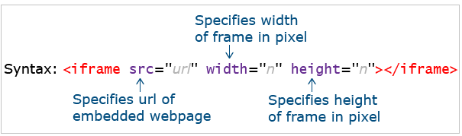
The below example demonstrates including a web page myPage.html on clicking on the hyperlink.
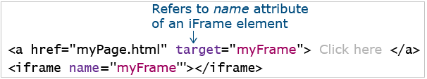

Problem Statement:
Create a web page called demo.html as below-mentioned.
Activity:
Change the value at the 'src' attribute to some valid link and observe the output.
Note: You can execute this tryout in your Visual Studio Code IDE or any other editors.
demo.html
- <html>
- <body>
- <iframe src="https://owasp.org/"
- width="1000" height="1000"></iframe>
- </body>
- </html>

Problem Statement:
Create a web page called demo.html as below-mentioned.
Activity:
Change the value of 'href' attribute to some other link and observe the output.
Note: You can execute this tryout in your Visual Studio Code IDE or any other editors.
demo.html
- <!DOCTYPE html>
- <html>
- <body>
- <p>This demo loads the target of hyperlink into the same web page using iframe</p>
- <a href="https://owasp.org/" target="myFrame">
- Click here to load webpage content into iframe.
- </a></br>
- <iframe name="myFrame" width="600" height="400"></iframe>
- </body>
- </html>

